



Computer Communications 27 (2004) 355–363

www.elsevier.com/locate/comcom

Interdomain trafﬁc engineering with redistribution communities

B. Quoitinª, S. Tandelª, S. Uhlig^{b}, O. Bonaventure^{b,}*
aInfonet group, University of Namur, Namur, Belgium
bDepartment of CSE, Catholic University of Louvain (UCL), Louvain-la-Neuve, Belgium
Received 8 August 2003; accepted 8 August 2003

Abstract
Various trafﬁc engineering techniques are used to control the ﬂow of IP packets inside large ISP networks. However, few techniques have
been proposed to control the ﬂow of packets between domains. In this paper, we focus on the needs of stub ISPs that compose 80% of the
global Internet. We ﬁrst describe the typical trafﬁc pattern of such a stub ISP. Then we brieﬂy describe the methods that those ISPs currently
use to engineer their interdomain trafﬁc. We focus on the control of the incoming trafﬁc and show the increasing utilization of the BGP
Community attribute and discuss the limitations of this approach. We then propose the redistribution communities as a deployable method to
control the ﬂow of the incoming interdomain trafﬁc. We implement those redistribution communities in zebra and evaluate its performance.
q 2003 Elsevier B.V. All rights reserved.
Keywords: Trafﬁc engineering; Border gateway protocol (BGP)

1. Introduction

Initially developed as a research network, the Internet has
been optimized to provide a service where the network does
its best to deliver packets to their destination. In the research
Internet, connectivity was the most important issue. During
the last years, we have seen a rapid growth and an increasing
utilization of the Internet to carry business critical services
such as e-commerce, Virtual Private Networks and Voice
over IP. To efﬁciently support those services, several
Internet Service Providers (ISP) rely on trafﬁc engineering
techniques to better control the ﬂow of IP packets.
During the last years, several types of trafﬁc engineer-
ing techniques have been developed [1]. Most of these
techniques have been designed for large IP networks that
provide transit services and need to optimize the ﬂow of
IP packets inside their internal network. These techniques
are of very limited use for smaller IP networks that
constitute most of the Internet today [2]. For these
networks, the costly resource that needs to be optimized is
usually their interdomain connectivity. Although some
BGP-based techniques are used today [3,4], it is difﬁcult

* Corresponding author.
E-mail addresses: bonaventure@info.ucl.ac.be (O. Bonaventure),
bqu@info.fundp.ac.be (B. Quoitin), sta@info.fundp.ac.be (S. Tandel),
suh@info.ucl.ac.be (S. Uhlig).
0140-3664/$ - see front matter q 2003 Elsevier B.V. All rights reserved.
doi:10.1016/j.comcom.2003.08.008

to use them to efﬁciently control the ﬂow of the incoming
interdomain trafﬁc. In this paper, we propose a deployable
technique that can be used to provide useful trafﬁc
engineering capabilities targeted at, but not limited to,
those small stubs.
This document is organized as follows. We ﬁrst discuss
in Section 2 the requirements for implementable and
deployable interdomain trafﬁc engineering techniques.
Then, we brieﬂy describe in Section 3 the existing
interdomain trafﬁc engineering techniques. We propose
the utilization of the redistribution communities in Section 4
to control the ﬂow of the incoming interdomain trafﬁc and
modify the zebra BGP daemon to support those commu-
nities in Section 5.

2. Requirements for interdomain trafﬁc engineering

The Internet is currently composed of about 14.000
Autonomous Systems (AS) [5] and its organization is more
complex than the research Internet of the early nineties.
Those 14.000 ASes do not play an equal role in the global
Internet. ASes can be distinguished on the basis of various
characteristics like the connectivity one AS has with its
peers, the services provided by one AS to its peers and the
behavior of the users inside the networks of one AS.

356

B. Quoitin et al. / Computer Communications 27 (2004) 355–363

First, ASes can be distinguished on the basis of their
connectivity. [2] has shown that there are two major types of
interconnections between distinct ASes: the customer –
provider and the peer-to-peer relationships. The customer –
provider relationship is used when a small AS purchases
connectivity from a larger AS. In this case, the large AS
agrees to forward the packets received from the small AS to
any destination and it also agrees to receive trafﬁc destined
to the small AS. On the other hand, the peer-to-peer
relationship is used between ASes of similar size. In this
case, the two ASes exchange trafﬁc on a shared cost basis.
According to [2], the customer-provider relationship is used
for about 95% of the AS interconnections in today’s
Internet.
Relying on this connectivity, [2] makes a ﬁrst character-
ization of ASes. There are basically two types of ASes:
transit ASes that constitute the core of the Internet and stub
ASes which are regional ISPs or customer networks that do
not provide transit. The core corresponds to about 15% of
the ASes in the Internet and can be divided in three different
subtypes (dense, transit and outer core depending on the
connectivity of each AS). Stub ASes correspond to 85% of
the Internet and they maintain only a few customer –
provider relationships with ASes in the core and some peer-
to-peer relationships with other small ASes.
In this paper, we do not address the trafﬁc engineering
needs of ASes in the core but rather focus on stub ASes. The
interested reader is referred to [6] for a discussion of the
needs of transit ASes in the core.
A second important element used to characterize an AS is
the type of customer it serves. If the AS is mainly a content
provider, it will want to optimize its outgoing trafﬁc since it
generates more trafﬁc than it receives. On the other hand, if
the AS serves a population of SMEs (Small and Medium
Enterprises), dialup, xDSL or cable modems users, it will
receive more trafﬁc than it sends. Such ASes will typically
only need to control their incoming trafﬁc.
Another point to consider is the ‘topological distribution’
of the interdomain trafﬁc to be engineered [7]. Although the
Internet is composed of about 14.000 ASes, a given AS will
not receive (resp. transmit) the same amount of trafﬁc from
(resp. toward) each external AS. The characteristics of the
interdomain trafﬁc seen from a customer AS have been
analyzed in details in Ref. [7]. In this paper, we have
analyzed the characteristics of all the interdomain trafﬁc
received by two small ISPs based on traces collected during
one week. The ﬁrst trace was collected at the interdomain
routers of Belnet, an ISP providing access to universities
and research labs in Belgium in December 1999. The second
trace was collected during one week in April 2001 at the
interdomain routers of Yucom, a Belgian ISP providing a
dialup access to the Internet. This study revealed two
important ﬁndings that are summarized in Fig. 1. First, the
left part of the ﬁgure shows the percentage of the number of
IP addresses that are reachable from the BGP routers of the
studied ASes at a distance of x AS hops. This ﬁgure shows

that for both studied ASes, most reachable IP addresses are
only a few AS hops away. Second, the right part of Fig. 1
shows the cumulative distribution of the trafﬁc received
from each external AS during the studied week.
The ﬁgure shows that for both ASes, a small percentage
of external ASes contribute to a large fraction of the
incoming trafﬁc. Hence, by inﬂuencing this limited
percentage of ASes a large fraction of the trafﬁc can be
engineered. Similar ﬁndings were reported in Ref. [6] for an
AS of the dense core.

3. Interdomain trafﬁc engineering today

In this section, we review the trafﬁc engineering
techniques that are in use today in the global Internet.
Since these techniques rely on a careful tuning of the BGP
routing protocol, we ﬁrst brieﬂy review its operation.

3.1. Interdomain routing

The Border Gateway Protocol (BGP) [8,9] is the current
de facto standard interdomain routing protocol (IDRP).
BGP is a path-vector protocol that works by sending route
advertisements between Autonomous Systems (ASes). A
route advertisement indicates the reachability of one IP
network through the router that advertises it either because
this network belongs to the same AS as this router or
because this router has received from another AS a route
advertisement for this network. Besides the reachable
network, each route advertisement also contains attributes
such as the AS-Path which is the list of all the transit ASes
that must be used to reach the announced network.
A key feature of BGP is that it supports routing policies.
That is, BGP allows a router to be selective in the route
advertisements that it sends to neighbor BGP routers in
remote AS. This is done by specifying on each BGP router a
set of input and output ﬁlters for each peer.

3.2. BGP-based trafﬁc engineering

The BGP-based trafﬁc engineering solutions in utiliz-
ation today rely on a careful tuning of the BGP decision
process¹that is used to select the best-route toward each
destination. This process is based on a set of criteria that act
as ﬁlters among all the BGP routes known by the router.

3.2.1. Control of the outgoing trafﬁc
The control of the outgoing trafﬁc is often a requirement
for content providers that wish to optimize the distribution
of their content. For this, they can rely on the local-pref
attribute to control the routes that will be chosen for

1 Due to space limitations, we cannot detail the BGP decision process in
this paper. A description of the BGP decision process may be found in Refs.
[3,4,6].

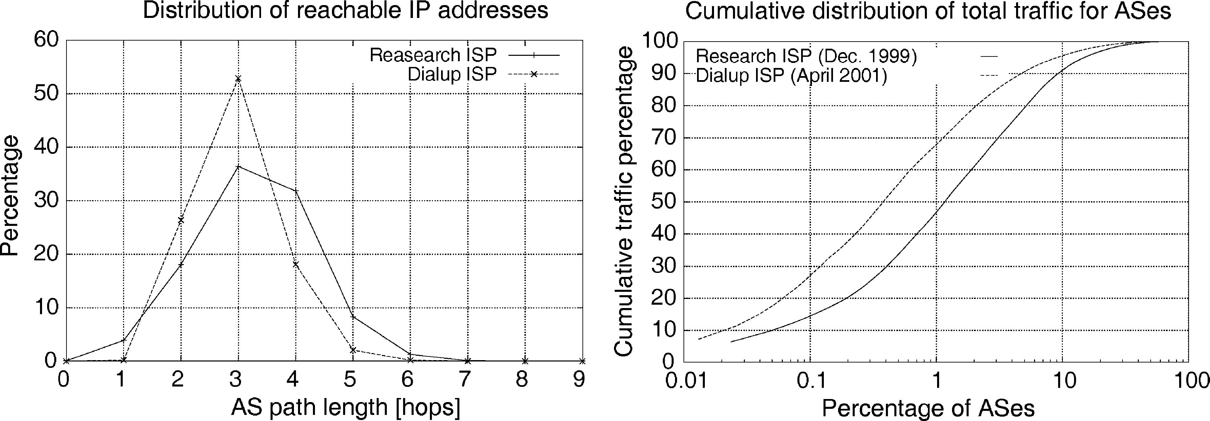
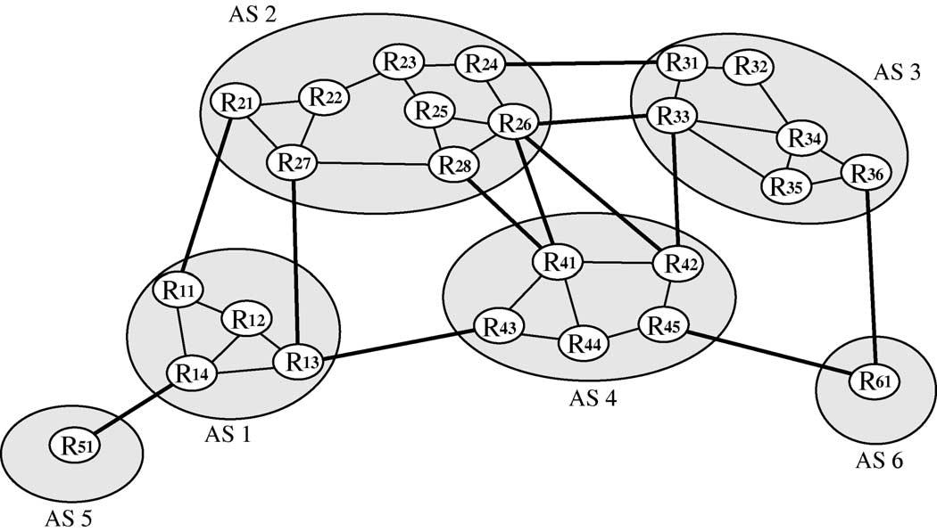

B. Quoitin et al. / Computer Communications 27 (2004) 355–363

Fig. 1. BGP routing tables (left) and cumulative distribution of total trafﬁc (right).

357

the packets that leave each BGP router of the content
provider [4]. The actual distribution of the outgoing trafﬁc
will depend on the quality of the setting of the local-
pref on the BGP routers of the AS. The setting of this
parameter can be done manually based on the knowledge of
the interdomain links or automatically with tools that rely on
trafﬁc measurements.

3.2.2. Control of the incoming trafﬁc
A customer AS serving a large number of individual
users or small corporate networks will typically have a very
asymmetric interdomain trafﬁc pattern with several times
more incoming than outgoing trafﬁc. These ASes typically
need to engineer their incoming trafﬁc only. For this, a ﬁrst
method that they can use is to announce different route
advertisements on different links. For example in Fig. 2, if
AS1 wanted to balance the trafﬁc coming from AS2 over the
links R₁₁– R₂₁and R₁₃– R₂₇; then it could announce only its

internal routes on the R₁₁– R₂₁link and only the routes
learned from AS5 on the R₁₃– R₂₇link. Since AS2 would
only learn about AS5 through router R₂₇; it would be forced
to send the packets whose destination belongs to AS5 via
router R₂₇:
A variant of the selective advertisements is the adver-
tisement of more speciﬁc preﬁxes. This advertisement relies
on the fact that an IP router will always select in its
forwarding table the most speciﬁc route for each packet (i.e.
the matching route with the longest preﬁx). This fact can
also be used to control the incoming trafﬁc. In the following
example, we assume that preﬁx 16.0.0.0/8 belongs to
AS3 and that several important servers are part of the
16.1.2.0/24 subnet. If AS3 prefers to receive the
packets toward its servers on the R₂₄– R₃₁link, then it would
advertise both 16.0.0.0/8 and 16.1.2.0/24 on this
link and only 16.0.0.0/8 on its other external links. An
advantage of this solution is that if link R₂₄– R₃₁fails, then

Fig. 2. A simple Internet.

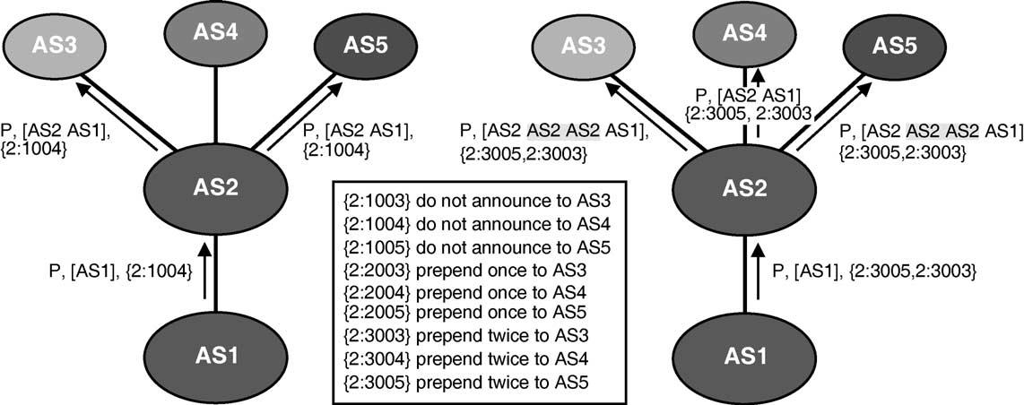

358

B. Quoitin et al. / Computer Communications 27 (2004) 355–363

subnet 16.1.2.0/24 would still be reachable through the
other links. However, an important drawback of advertising
more speciﬁc preﬁxes is that it increases the number of
BGP advertisements and thus the size of the BGP routing
tables [10].
Another method would be to allow an AS to indicate a
ranking among the various route advertisements that it
sends. Based on the BGP decision process, one possible way
to introduce a ranking between routes is to artiﬁcially
increase the length of the AS-Path attribute. Coming back
to our example, AS1 would announce the routes learned
from AS5 on links R₁₁– R₂₁and R₁₃– R₂₇; but would attach a
longer AS-Path attribute (e.g. AS1 AS1 AS1 AS5 instead
of AS1 AS5) on the R₁₃– R₂₇link. The required amount of
prepending is often manually selected on a trial and error
basis. The manipulation of the AS-Path attribute is often
used in practice ([10] reports that this affected 6.5% of the
BGP routes in November 2001). However, it should be
noted that this technique is only useful if the ASes that we
wish to inﬂuence do not rely on local-pref.

3.2.3. Community-based trafﬁc engineering
In addition to these techniques, several ASes have been
using the BGP Community attribute to encode various
trafﬁc engineering actions [11]. This attribute is often used
to add markers to announced routes and to simplify the
implementation of scalable routing policies on BGP
routers. The community attribute is a transitive attribute
that contains a set of community values, each value being
encoded as a 32 bits ﬁeld. Some community values are
standardized (e.g. NO_EXPORT), but the Internet
Assigned Numbers Authority (IANA) has assigned to
each AS a block of 65536 community values. The
community values are usually represented as ASx:V
where ASx is the AS number to which the community
belongs and V a value assigned by ASx. The community
attribute is often used to encode the following trafﬁc
engineering actions [11]:

(1) Do not announce the route to speciﬁed peer(s);
(2) Prepend n times the AS-Path (where we have found
values for n generally ranging from 1 to 3) when
announcing the route to speciﬁed peer(s);
(3) Set the local-pref value in the AS receiving the
route [12];

In the ﬁrst case, the community is attached to a route
to indicate that this route should not be announced to a
speciﬁed peer or at a speciﬁed interconnection point. For
example, in the left part of Fig. 3, AS2 has conﬁgured
its routers to not announce to AS4 routes that contain the
2:1004 community. AS2 has documented the utilization
of this community to its peers so that AS1 can attach
this value to the routes advertised to AS2 to ensure that
it does not receive packets from AS4 through AS2. In a
detailed survey of the RIPE whois database [11], we
have shown that this type of communities was often used
by ISPs.
The second type of community is used to request the
upstream AS to perform AS-Path prepending for the
associated route. The right part of Fig. 3 shows how AS1
uses the 2:3003 and 2:2005 communities documented
by AS2 to request that the AS-Path of the route it
announced be prepended twice when announced to AS3
and AS5. To better understand the usefulness of such
community values, let us consider again Fig. 2, and
assume that AS6 receives a lot of trafﬁc from AS1 and
AS2 and that it would like to receive the packets from
AS1 (resp. AS2) on the R₄₅– R₆₁(resp. R₃₆– R₆₁) link.
AS6 cannot achieve this type of trafﬁc distribution by
performing prepending itself. However, this would be
possible if AS4 could perform the prepending when
announcing the AS6 routes to external peers. AS6 could
thus advertise to AS4 its routes with the community
4:5202 (documented by AS4) that indicates that
this route should be prepended two times when
announced to AS2.

Fig. 3. Examples of trafﬁc engineering with communities.

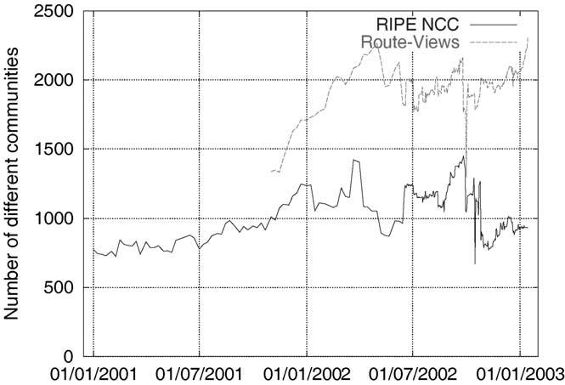

B. Quoitin et al. / Computer Communications 27 (2004) 355–363

359

Finally, the third common type of community used for
trafﬁc engineering purposes is to set the local-pref in
the upstream AS as described in Ref. [12].

4. Redistribution communities

The community based trafﬁc engineering solution
described in Section 3 has been deployed by several dozens
ISPs [11], but it suffers from several important drawbacks
that limit its widespread utilization. First, each AS can only
deﬁne 65536 distinct community values. While in practice
no AS today utilizes more than 65536 community values,
this limited space forces each AS to deﬁne its own
community values in an unstructured manner. We note
however, that facing the need for structured community
values, some ASes like AS9057 have started to utilize
community values outside their allocated space [11] and
that other ASes are using community values reserved for
standardization. This shows that there is a clear need for
more structured community values.
A second drawback is that each deﬁned value must be
manually encoded in the conﬁgurations of the BGP routers
of the AS. This is usually done by deﬁning a ﬁlter for each
supported community. In practice, a large number of ﬁlters
are required to support complex policies. Deﬁning a large
number of such ﬁlters increases the complexity of the
conﬁgurations. Furthermore, since those ﬁlters need to be
applied to each BGP message, this can signiﬁcantly increase
the processing time of the BGP messages.
A third drawback is that each AS willing to utilize such
communities must advertise the semantic of its own
community values to external peers. Unfortunately, there
is no standard method to advertise these community values.
Some ASes deﬁne their communities as comments in their
routing policies that are stored in the Internet Routing
Registries. The RPSL language [13] used for these
speciﬁcations does not currently allow to easily deﬁne the
semantic of the community attribute values. Other ASes
publish the required information on their web server or
distribute it directly to their clients. This implies that an AS
willing to utilize the trafﬁc engineering communities
deﬁned by its upstream ASes needs to manually insert
directives in the conﬁgurations of its BGP routers. Once
inserted, these directives will need to be maintained and
checked if the upstream AS decides for any reason to
modify the semantics of some of its community values. This
increases the complexity of the conﬁguration of the BGP
routers and is clearly not a desirable solution. A recent study
has shown that human errors are already responsible for
many routing problems on the global Internet [14]. An
increasing utilization of this type of community-based
trafﬁc engineering would probably cause even more errors.
A fourth drawback of the BGP community attribute is its
transitivity. It implies that once a community value has been
attached to a route, this community is distributed throughout

the global Internet. The growth of the BGP routing tables
has been an important operational problem during the last
few years due to the limited memory capacity of several
deployed routers. Several studies [5] have analyzed the
growth of the BGP routing tables based on the number of
routes contained in those tables and have provided
explanations for this growth. However, those BGP routing
tables also store optional BGP attributes such as the
community attribute that may contribute to the growth of
the memory occupancy of those tables.

4.1. Current usage of the community attribute

To evaluate the impact of the communities on the size of
the BGP tables, we have analyzed the utilization of the
community attribute in the BGP routing tables collected by
RIPE RIS [15] and the Route Views projects [16] from
January 2001 until January 2003 (The Route-Views project
started in November 2001). For this analysis, we down-
loaded one BGP table dump per week until the end of June
2002 and then one BGP table per day. We parsed each BGP
table to determine the number of routes containing
community values and the number of distinct communities.
A ﬁrst observation of those BGP table dumps reveals that
although most of the community values have a local
semantics [11], a large number of community values appear
in the BGP routing tables. Fig. 4 shows the evolution of the
number of distinct community values found in those routing
tables. The evolution of the utilization of the communities
reveals a sustained growth since the availability of the ﬁrst
dumps with community information in January 2001. For
instance, in recent dumps, we can ﬁnd more than 900
different community values in routing tables collected by
RIPE and more than 2300 distinct values in routing tables
collected by Route-Views. This large number of distinct
values shows the need for a structured and standardized
encoding of the communities since there are many different

Fig. 4. Evolution of the number of distinct community values.

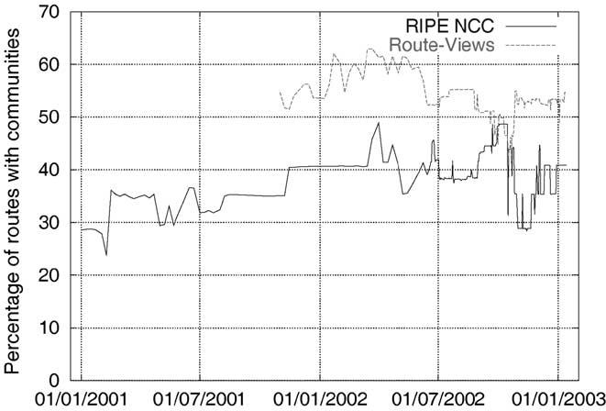

360

B. Quoitin et al. / Computer Communications 27 (2004) 355–363

† the attached route should not be announced to the
speciﬁed BGP speakers.
† the attached route should only be announced to the
speciﬁed BGP speakers.
† the attached route should be announced with the
NO_EXPORT community to the speciﬁed BGP
speakers.
† the attached route should be prepended n times when
announced to the speciﬁed BGP speakers.

The encoding of the redistribution action as well as the
various ways to specify the target BGP speakers are deﬁned
in Ref. [18]. Compared with the classical communities, an
interesting feature of the redistribution communities is that

Fig. 5. Evolution of the percentage of routes carrying communities.

utilizations of communities but also different values used for
a similar meaning.
Another important element to consider is the number
of routes carrying the community attribute (Fig. 5 shows
the evolution of the percentage of routes which carry at
least one community). From January 2001 to January
2003, the number of routes in the RIPE tables has grown
from 1.2 to nearly 1.4 M routes while the number of
routes which have at least one community attached has
evolved from 366 (29%) to 568 k (41%) routes. From
November 2001 to January 2003, the size of the tables
collected at Route-Views changed from 1.8 to 2.8 M
routes while the number of routes that carry at least one
community has evolved from 1 (55%) to 1.5 M (53%)
routes. If we count the total number of communities
present in the tables during the above periods, we can
see that it has grown from 840 k to 1.4 M communities
at RIPE and from 2.2 to 5.5 M communities at Route-
Views. These large amounts are mainly due to the
transitivity of the community attribute. Most of the
community values contained in those tables have no
meaning for the global Internet.

4.2. The redistribution communities

In order to avoid the problems of the classical
communities which we have identiﬁed in Section 4.1,
we propose a new type of extended community attribute,
the redistribution communities. First, the extended
community attribute deﬁned in Ref. [17] provides a
more structured and larger space, 8 octets, than the
community attribute. Second, one ﬂag in extended
communities can be used to request non-transitivity.
The redistribution communities we deﬁned can be used
to encode a set of redistribution actions that are
applicable to a set of BGP speakers. The current
deﬁnition of the redistribution communities [18] supports
the following actions:
there are two methods to specify the BGP speakers affected
by an action. The ﬁrst method is to explicitly list all those
BGP speakers (e.g. their AS number) inside the redistribu-
tion communities. This method can be used for example
when a route must be prepended when announced to a few
speciﬁc ASes. The second method is to explicitly list only
the eBGP speakers that will not be affected by the speciﬁed
action. In this case, it is possible to specify that a route
should be prepended once when announced to external peers
except for a few speciﬁed peers.
It should be noted that the BGP redistribution commu-
nities that we propose are not equivalent to the DIS-
T_LIST_INCL and DIST_LIST_EXCL attributes
supported by ISO’s IDRP [19]. IDRP’s transitive DIS-
T_LIST_INCL (resp. DIST_LIST_EXCL) attribute
allows a domain to specify the list of domains that are
allowed (resp. prohibited) to receive the attached route. Our
redistribution communities support more actions, but are
non-transitive. Using those two IDRP attributes in today’s
Internet would probably cause a severe security concern
since a transit AS could create severe routing problems by
modifying the content of such attributes inside received
routes.

5. Implementation of the redistribution communities

In order to evaluate the cost of supporting the
redistribution communities in a BGP router, we have
modiﬁed the zebra BGP daemon [20]. The implemen-
tation of the redistribution communities requires two
distinct functionalities. The ﬁrst one is to allow a network
operator to specify the redistribution communities that must
be attached to given routes and the second one is to
inﬂuence the redistribution of the routes that have such
communities attached.
First, in order to allow a network operator to attach
redistribution communities to routes, we have extended the
route-map statement available in the command-line
interface (CLI) of zebra. The route-map statement is
an extremely powerful and versatile tool for route ﬁltering
and attribute manipulation that is composed of a ﬁlter and

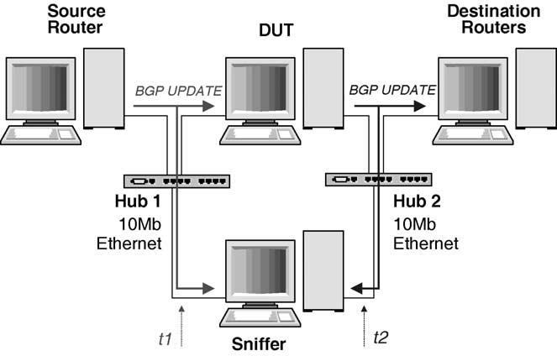
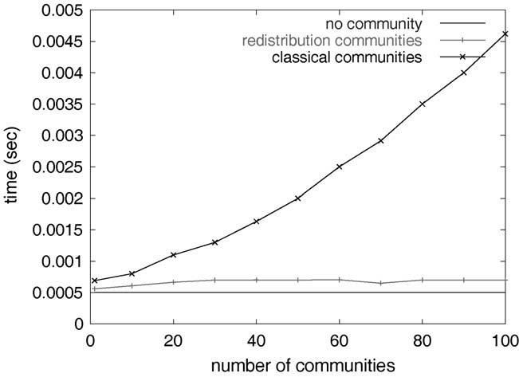

B. Quoitin et al. / Computer Communications 27 (2004) 355–363

a list of actions. Our extension consists in the addition of a
new action that can be used to attach a list of redistribution
communities to routes that match the route-map ﬁlter.
An example of a route-map using our new action is given
below. The example presents the conﬁguration in routers of
AS6. This conﬁguration attaches a redistribution commu-
nity to every route announced to AS4. This community
requests that AS4 prepend 2 times the AS-PATH of routes
announced by AS6 when redistributing to AS2 (see example
in Section 3.2.3).

neighbor kas4-neighbor-ipl route-map
prepend2_to_as2

361

route-map prepend2_to_as2 permit 10
match ip address any
set extcommunity red prepend(2):as(2)

Then, we have modiﬁed zebra so that redistribution
communities are automatically taken into account. The
implementation extracts the redistribution communities
attached to the route and on the basis of their content,
decides to attach the NO_EXPORT community, to prepend n
times or to ignore the route when redistributing to speciﬁed
peers. This automatic treatment requires that all the
redistribution communities attached to a route be treated
together in order to check that conﬂicting actions are not
taken in account. Moreover, it is possible to setup in
different redistribution communities overlapping ﬁlters
associated to different actions. In this case, the implemen-
tation is responsible for applying the action which implies
the smallest amount of modiﬁcations to the treatment of the
route, as stated in the speciﬁcations. These modiﬁcations in
the source code of zebra were quite limited compared to
the amount of work required to conﬁgure by hand
redistribution policies similar to what redistribution com-
munities provide.

5.1. Performance evaluation

In order to estimate the performance of the implemen-
tation of the redistribution communities in zebra, and to
compare their efﬁciency to routing policies based on
classical communities, we have performed black-box
measurements of the time taken by a Linux machine
running the zebra BGP daemon to propagate an UPDATE
message received from one peer to other peers. For
reference purpose, we ﬁrst performed measurements with
routes without the community attribute. Then we performed
a second set of measurements with routes containing
classical communities and a BGP router supporting the
corresponding routing policies. Finally, we performed
measurements with routes containing redistribution
communities.
The testbed used for the measurements is shown in Fig. 6.
Four Linux machines have been interconnected. In the
center of the topology, the Device Under Test (DUT) runs a
Fig. 6. Measurement testbed.

zebra BGP daemon supporting the redistribution commu-
nities. On the left, the Source Router also runs zebra and
has an eBGP session established with the DUT. The Source
Router produces test BGP UPDATE messages. On the right,
the Destination Router is a PC which simulates the multiple
downstream BGP peers of the DUT. The Destination
Routers runs one sbgp daemon per simulated peer instead
of full BGP daemons. Finally, the Sniffer runs tcpdump to
capture the messages that arrive/leave to/from the DUT.
For our ﬁrst measurements, we measured the time
required to process the routes learned from and external
peer and to announce them to a single Destination Router.
Without communities or redistribution communities, the
DUT required on average 0.5 ms to process a single BGP
UPDATE message (bottom line in Fig. 7).
We then used classical and redistribution communities to
request the DUT to perform AS-Path prepending. With the
classical communities, the conﬁguration of the DUT
contains one community-list and one matching
route-map statement for each supported classical com-
munity. Fig. 8 shows an extract of the conﬁguration of the
DUT with those communities. No special conﬁguration was

Fig. 7. Average time to process and announce routes to a single peer.

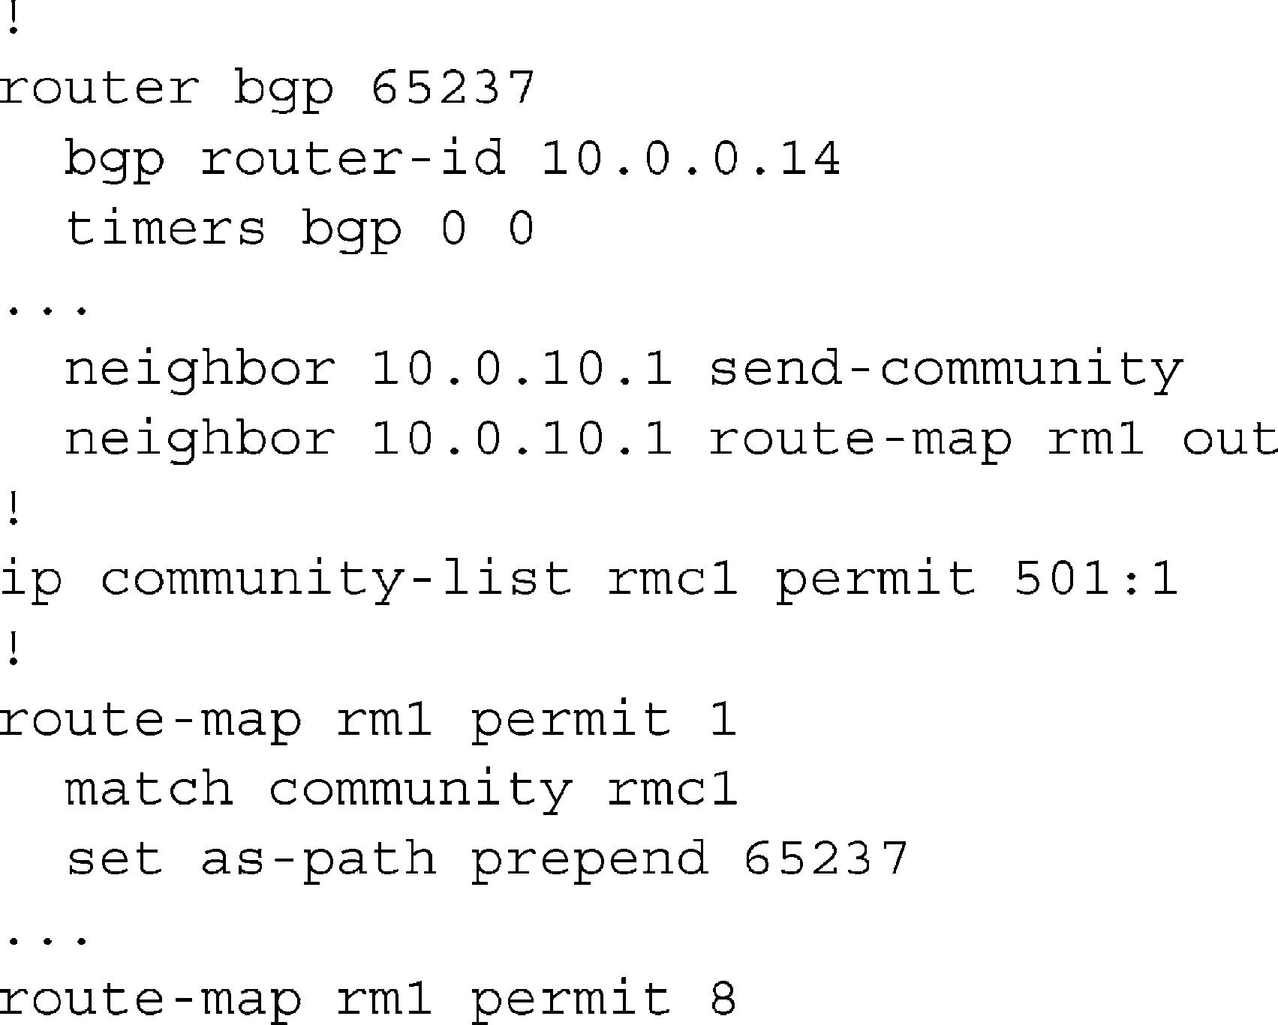
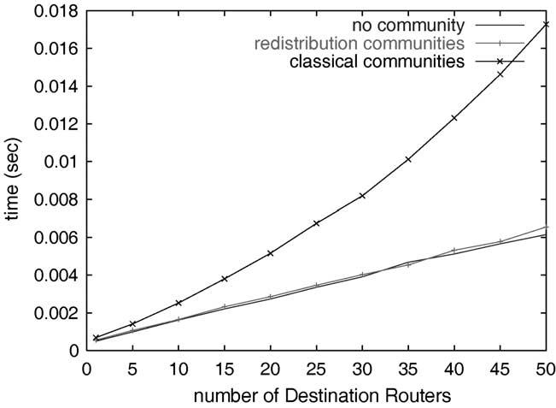

362

B. Quoitin et al. / Computer Communications 27 (2004) 355–363

Fig. 8. Conﬁguration of the DUT with classical communities.
Fig. 9. Average time to process and announce routes to m peers.

required on the DUT to support the redistribution
communities.
As expected, the utilization of optional BGP attributes
increases the processing time. The measurements indicate
that the DUT spends 0.69 ms on average to process and
announce a route with a single classical community
attached, 0.56 ms with a single redistribution community.
With the classical communities, the time required to process
and announce a route increases quickly with the number of
distinct communities contained in the route and conﬁgured
on the DUT. For example, the DUT spends 4.62 ms to
process and announce a route containing 100 classical
communities. On the other hand, the number of redistribu-
tion communities does not appear to increase signiﬁcantly
the processing time of the DUT. For instance, the DUT
spends on average 0.7 ms to process and announce a route
containing 100 distinct redistribution communities.
We then performed a second experiment to model a
router connected to a large number of peers such as on a
public Internet eXchange (IX). For this experiment, we used
a single community but varied the number of external peers.
Fig. 9 represents the average time to process and announce
this route to m peers. This experiment shows that the
utilization of redistribution communities does not affect the
time to process and announce a route to m peers. However,
when classical communities are used, this time increases
quickly with the number of peers. For instance, with 50
peers, the average time taken by the DUT to process and
announce a route is 17.28 ms with a single classical
community and 87.5 ms with 100 classical communities.
In the case of redistribution communities, these times are
6.55 and 10.3 ms, respectively. We can conclude that the
processing time is more sensitive to the number of
communities attached when classical communities are
used than with redistribution communities.
The important difference observed in the time taken to
process and announce routes with classical or redistribution
communities is mainly due to the requirements that were in

mind when those two techniques have been designed. The
classical communities are processed like other BGP
attributes in the routing policies and it is possible to build
ﬁlters that match the communities attribute in complex
ways. The provision of such a generic ﬁltering framework
requires more processing time than the speciﬁc scheme of
redistribution communities. Moreover, with zebra or
commercial BGP daemons [3], a large number of ﬁlters
need to be deﬁned to provide, with classical communities,
the same functionalities as redistribution communities. With
zebra one ﬁlter is required per peer and per redistribution
action. This explains the need for more and more time when
the number of peers or/and the number of communities
increase.

6. Perspectives

Many stub ISPs need to engineer the ﬂow of their
interdomain trafﬁc. While content providers can rely on the
local-pref attribute to engineer their outgoing trafﬁc,
access providers do not have techniques to control their
incoming trafﬁc. In this paper, we have proposed the
utilization of redistribution communities to allow ISPs to
control the ﬂow of their incoming trafﬁc by controlling the
distribution of their route advertisements by their peers or
upstream providers. Redistribution communities have two
major advantages compared to the utilization of classical
community values. First, the redistribution communities
have a standardized semantics. This simpliﬁes signiﬁcantly
the conﬁguration of BGP routers and thus reduces the risk of
errors. Second, the redistribution communities are non-
transitive. This suppresses the risk of polluting all BGP
routing tables.
We have then modiﬁed the zebra BGP routing daemon
to support our proposed redistribution communities and
evaluated the performance of this daemon. Our measure-
ments indicate that the redistribution communities introduce

B. Quoitin et al. / Computer Communications 27 (2004) 355–363

363

a much smaller processing overhead that the classical
communities.
We expect that the redistribution communities will be
quickly deployed by ISPs to replace their complex BGP
conﬁgurations with classical communities. It can be
expected that initially the redistribution communities will
be set manually by the network operators like the classical
communities today. However, given the standardized
semantics of the redistribution communities, it would be
possible to deﬁne heuristics to automatically set redistribu-
tion communities to achieve a given distribution of the
incoming trafﬁc based for example on the BGP routing
tables received from the upstream peers and trafﬁc statistics.

Acknowledgements

This work was partially supported by the European
Commission within the IST ATRIUM project. We would
like to thank Russ White, Stefaan De Cnodder and Jeffrey
Haas for their help in the development of the redistribution
communities. The trafﬁc traces were provided by Benoit
Piret and Marc Roger. We thank, RIPE for their whois
database and their RIS project and Route Views for their
routing tables.

References

[1] D. Awduche, A. Chiu, A. Elwalid, I. Widjaja, X. Xiao, Overview and
principles of internet trafﬁc engineering, RFC3272, May 2002.
[2] L. Subramanian, S. Agarwal, J. Rexford, R. Katz, Characterizing the
internet hierarchy from multiple vantage points, In INFOCOM 2002,
June, 2002.
[3] B. Halabi, Internet Routing Architectures, Cisco Press, 1997.
[4] B. Quoitin, S. Uhlig, C. Pelsser, L. Swinnen, O. Bonaventure,
Interdomain trafﬁc engineering with BGP, IEEE Communications
Magazine, May 2003.
[5] G. Huston, AS1221 BGP table statistics. available from http://www.
telstra.net/ops/bgp/, 2003.

[6] N. Feamster, J. Borkenhagen, J. Rexford. Controlling the impact of
BGP policy changes on IP trafﬁc. Technical report 011106-02, AT and
T Research, November 2001.
[7] S. Uhlig, O. Bonaventure, Implications of interdomain trafﬁc
characteristics on trafﬁc engineering, European Transactions on
Telecommunications, January 2002.
[8] J. Stewart, BGP4: Interdomain Routing in the Internet, Addison
Wesley, 1999.
[9] Y. Rekhter, T. Li, S. Hares., A border gateway protocol 4 (BGP-4),
Internet draft, draft-ietf-idr-bgp4-20.txt, work in progress, April
2003.
[10] A. Broido, E. Nemeth, K. Claffy, Internet expansion, reﬁnement
and churn, European Transactions on Telecommunications, January
2002.
[11] O. Bonaventure, B. Quoitin, Common utilizations of the BGP
community attribute Internet draft, draft-bq-bgp-communities-00.txt,
work in progress, June 2003, available from http://www.info.ucl.ac.
be/people/OBO/biblio.html
[12] E. Chen, T. Bates, An application of the bgp community attribute in
multi-home routing. Internet Engineering Task Force, RFC1998,
August 1998.
[13] C. Alaettinoglu, C. Villamizar, E. Gerich, D. Kessens, D. Meyer, T.
Bates, D. Karrenberg, M. Terpstra, Routing Policy Speciﬁcation
Language (RPSL). Internet Engineering Task Force, RFC2622, June
1999.
[14] R. Mahajan, D. Wetherall, T. Anderson, Understanding BGP
misconﬁgurations, In ACM SIGCOMM, 2002, August 2002.
[15] Routing Information Service project. Reґseaux IP Europeґens, http://
www.ripe.net/ripencc/pub-services/np/ris-index.html, January 2002.
[16] D. Route Views Archive project. University of Oregon, http://archive.
routeviews.org, January 2002.
[17] S. Sangli, D. Tappan, Y. Rekhter, BGP extended communities
attribute, Internet draft, draft-ietf-idr-bgp-ext-communities-06.txt,
work in progress, August 2003.
[18] O. Bonaventure, S. De Cnodder, J. Haas, B. Quoitin, R. White,
Controlling the redistribution of BGP routes, Internet draft, draft-ietf-
grow-bgp-redistribution-00.txt, work in progress, April 2003, avail-
able from http://www.info.ucl.ac.be.people/OBO/biblio.html
[19] ISO/IEC, Information processing systems—telecommunications
and information exchange between systems-protocol for exchange
of inter-domain routeing information among intermediate systems
to support forwarding of iso 8473 pdus, ISO/IEC 10747:1993
(1993).
[20] K. Ishiguro, GNU zebra-routing software. available from http://www.
zebra.org, 2001.

